

MBARARA UNIVERSITY OF SCIENCE AND TECHNOLOGY

FACULTY OF COMPUTING AND INFORMATICS

BARCHELORS OF SCIENCE COMPUTER SCIENCE

CSC1204 DATABASE SYSTEMS

ASSIGNMENT: PROJECT 1

LECTURER: KENETH BAGUMA

NAME: RUKUNDO EMMANUEL

REG NUMBER: 2025/BCS/168/PS

YEAR 1: SEMESTER: 2

DATABASE NAME: BAKERY SYSTEM

TABLE OF CONTENT
- Executive Summary ……………………………………………………...........

- Business case………………………………………………………………....

  - Application domain……………………………………………........

  - Benefit analysis.......................................................................................

  - Cost analysis ……………………………………………………………

  - User analysis……………………………………………………………

  - Risk assessment…………………………………………………………

  - System limitations………………………………………………………
- Design ……………………………………………………………………...........
3.1. Logical design ………………………………………………………………
3.1.1. List of entities ………………………………………………………….....
3.1.2. Entities and attributes ……………………………………………………
3.1.3. Entity relationships……………………………………………...................
3.1.4. Multiplicities……………... ...…………………..........................................
3.1.5. Entity relationship diagram……………………………………………...
3.1.6. User interfaces…………………………………………………………….
3.2. Physical Design ……………………………………...............………………
3.2.1. Database schema……………………………...............……………………
3.2.2. Sample queries and reports generated by the system…………………...

DATABASE SYSTEMS PROJECT:
BAKERY CUSTOMER MANAGEMENT SYSTEM
Prepared by: RUKUNDO EMMANUEL
Course: Database Management Systems
Date: 06 May 2025

1. Executive Summary
In the modern retail landscape, particularly within the artisanal food sector, data has become as essential as raw ingredients. This project focuses on the design and implementation of a Customer Relationship and Order Management System for 'The Crust & Crumb Bakery.' The bakery currently operates using manual, paper-based processes for order tracking and customer management, leading to inefficiencies, data loss, and missed marketing opportunities. The developed system leverages a MySQL relational database to centralize all business operations. By structuring data into distinct entities such as Customers, Products, and Orders, the bakery can now track individual customer preferences, manage complex pre-orders for events, and implement a data-driven loyalty program. This report outlines the business case for such a system, details the logical and physical database designs, and demonstrates the system's utility through complex SQL queries and reporting structures.

2. Business Case

a. Application Domain
The application domain encompasses the daily operational environment of a mid-sized bakery. This system is designed to support the following key functional areas:
- • Point of Sale Support: Capturing real-time transaction data at the counter.
- • Order Management: Tracking specialized orders for cakes and large-scale catering events, including status updates (e.g., Pending, Baking, Ready for Pickup).
- • Customer Relationship Management (CRM): Maintaining a repository of customer contact details, purchase history, and allergen information.
- • Loyalty Programming: Managing a points-based system to encourage repeat business.
The primary user groups include the Bakery Staff, who require a fast interface for transaction entry, and Bakery Management, who require reporting tools to analyze sales performance and inventory turnover.

b. Analysis of Benefits
The transition to a digital database offers both tangible and intangible benefits. Tangible benefits include a projected 15% reduction in order processing time and a significant decrease in 'waste' costs resulting from miscommunicated custom order details. By having a digital record, the bakery can also automate 'Happy Birthday' discount emails, which industry standards suggest can increase monthly foot traffic by 5-10%. Intangible benefits include improved employee morale due to less stressful record-keeping and enhanced professional credibility with customers who receive automated SMS notifications when their orders are ready.

c. Analysis of Costs
Economic feasibility is determined by comparing the initial investment against long-term gains. Estimated tangible costs include:
Item | Description | Cost Est.(shs.
Hardware | Desktop PC/Tablet for POS | 2,000,000
Software/Hosting | MySQL Server (Cloud Hosting) | 70,000/@month
Training | Staff hours for system onboarding | 1,000,000/=
The total first-year investment is estimated at approximately shs2,070,000/=. Given the projected waste reduction and loyalty revenue, the system is expected to reach a 'break-even' point within 5 months of full deployment.

d. User Issues
One of the primary challenges in implementing this system is the technical skill gap among existing staff. Many employees have worked in the traditional baking environment for decades and may resist moving away from paper logs. To address this, the system's UI must be intuitive, employing a 'touch-first' design. Adoption effort will be managed through a two-week transition period where both paper and digital systems run in parallel.

e. Risks Assessment
Several risks have been identified:
- • Technical Risk: Database downtime during peak hours could halt sales. This will be mitigated by implementing local caching and automated daily cloud backups.
- • Data Integrity: Errors in manual data entry (e.g., misspelled emails) could render the CRM useless. Data validation rules will be enforced at the database level.

f. Limitations
The current system is restricted to internal local network use and does not yet feature a public-facing web API for online ordering. Furthermore, while it tracks inventory levels, it does not automatically trigger orders to flour and yeast suppliers; this remains a manual managerial task.

3. Design: Logical and Physical

a. List of Entities
The system is built around five core entities: Customers, Employees, Products, Orders, and OrderDetails.

b. Entities and Attributes
- • Customers: CustomerID (PK), FirstName, LastName, Phone, Email, Birthday, Points Balance, Join Date.
- • Products: ProductID (PK), ProductName, Category, UnitPrice, StockQuantity, AllergenInfo.
- • Orders: OrderID (PK), CustomerID (FK), EmployeeID (FK), OrderDate, TotalPrice, OrderStatus.
- • OrderDetails: DetailID (PK), OrderID (FK), ProductID (FK), Quantity, ItemSubtotal.

c, d & e. ERD and Relationships

CUSTOMERS
PK: customer_id
first_name
last_name
email (Unique)
phone
allergies
loyalty_points
ORDERS
PK: order_id
FK: customer_id
order_date
pickup_date
total_amount
status (ENUM)

PRODUCTS
PK: product_id
item_name
category (ENUM)
price_per_unit
stock_quantity
ORDER_ITEMS
PK: order_item_id
FK: order_id
FK: product_id
quantity
subtotal

KEY MEANS(1:N)
The relationships are structured as follows:
• Customer to Orders: One-to-Many (1:N). A customer can place many orders over time, but each order is linked to one primary customer profile.
• Order to OrderDetails: One-to-Many (1:N). This handles the 'line items' of a receipt.
• Product to OrderDetails: One-to-Many (1:N). A specific product (e.g., Croissant) can appear in many different order records.
The multiplicity ensures that data is normalized, preventing the redundancy of storing customer names inside every order record. Instead, only the CustomerID is stored as a Foreign Key.

f. User Interface Design
The dialogue structure follows a linear progression: 1. Customer Identification: Lookup by phone number. 2. Product Selection: Visual grid of bakery items. 3. Payment Processing: Calculation of total and application of loyalty points. 4. Confirmation: Printing of receipt and updating inventory tables.

4. Implementation

g. Physical Database Schema
Below is the SQL implementation used to generate the schema in MySQL Workbench.
CREATE DATABASE Customers;
USE Customers;
CREATE TABLE Customers (
CustomerID INT AUTO_INCREMENT PRIMARY KEY,
FirstName VARCHAR(50) NOT NULL,
LastName VARCHAR(50) NOT NULL,
Phone VARCHAR(15) UNIQUE,
Email VARCHAR(100),
Birthday DATE,
PointsBalance INT DEFAULT 0
);
CREATE TABLE Products (
ProductID INT AUTO_INCREMENT PRIMARY KEY,
ProductName VARCHAR(100),
Category ENUM ('Bread', 'Pastry', 'Cake', 'Beverage'),
UnitPrice DECIMAL(10, 2),
StockQuantity INT
);
CREATE TABLE Orders (
OrderID INT AUTO_INCREMENT PRIMARY KEY,
CustomerID INT,
OrderDate DATETIME DEFAULT CURRENT_TIMESTAMP,
TotalAmount DECIMAL (10, 2),
FOREIGN KEY (CustomerID) REFERENCES Customers (CustomerID)
);
CREATE TABLE OrderDetails (
DetailID INT AUTO_INCREMENT PRIMARY KEY,
OrderID INT,
ProductID INT,
Quantity INT,
Subtotal DECIMAL(10, 2),
FOREIGN KEY (OrderID) REFERENCES Orders (OrderID),
FOREIGN KEY (ProductID) REFERENCES Products (ProductID)
);

5. Sample Queries and Results
Management requires specific insights to drive decision-making. The following queries represent the most frequent business requests.
1. The Daily Dashboard Query
This query retrieves all orders placed on the current date for management review:
SELECT order_id, total_amount, status FROM Orders WHERE DATE(order_date) =
CURDATE();
2. Low Stock Alert
This query identifies products requiring immediate replenishment:
SELECT item_name, stock_quantity FROM Products WHERE stock_quantity &lt; 5;
3. Customer Allergy Verification
Safety is a priority; this query checks for specific customer dietary restrictions:
SELECT first_name, last_name, allergies FROM Customers WHERE allergies IS NOT
NULL;

IMPLEMENTATION
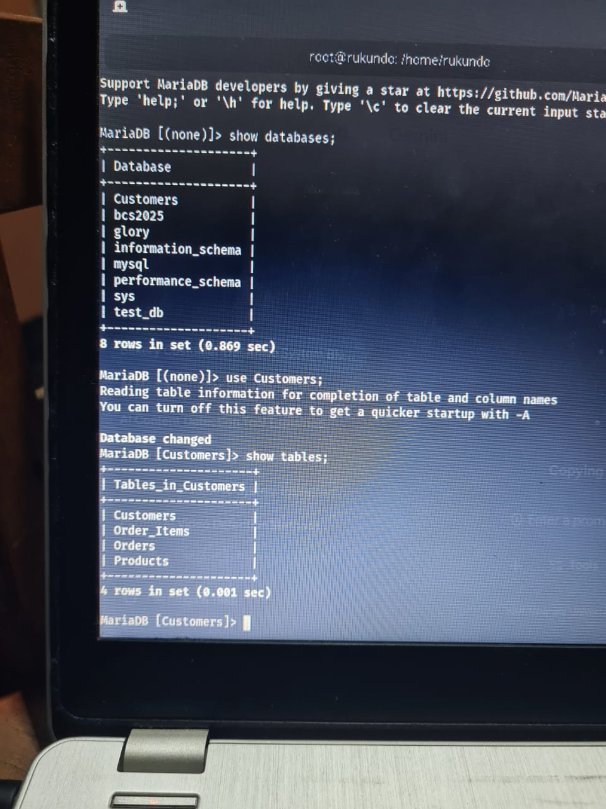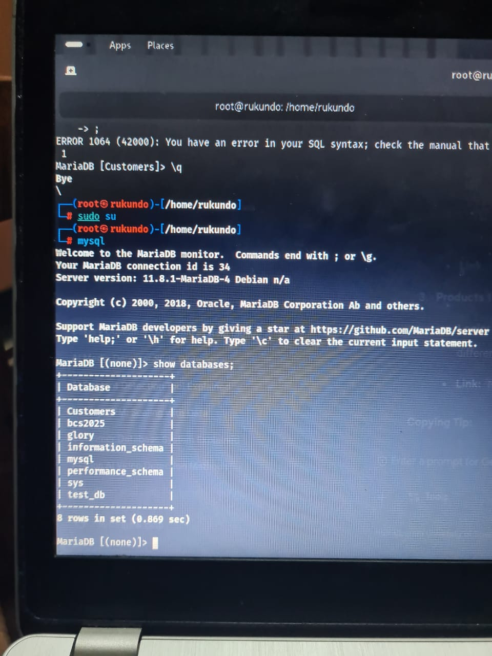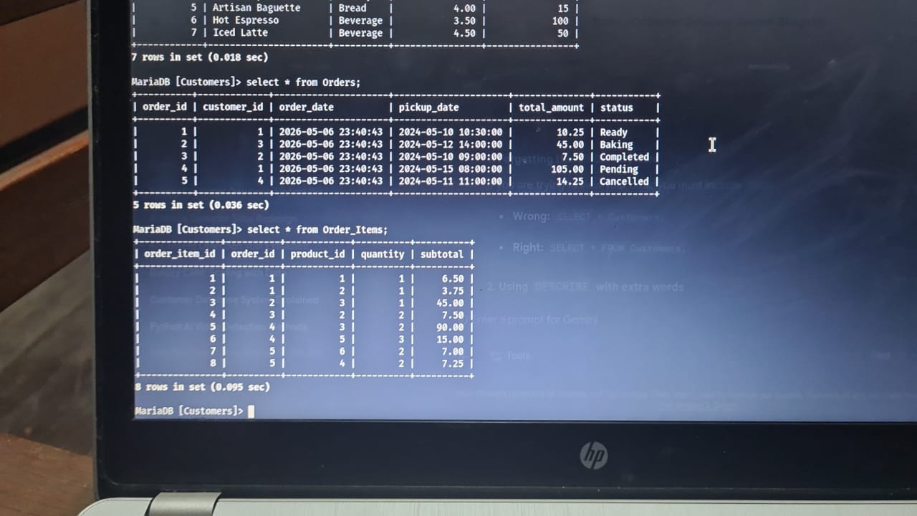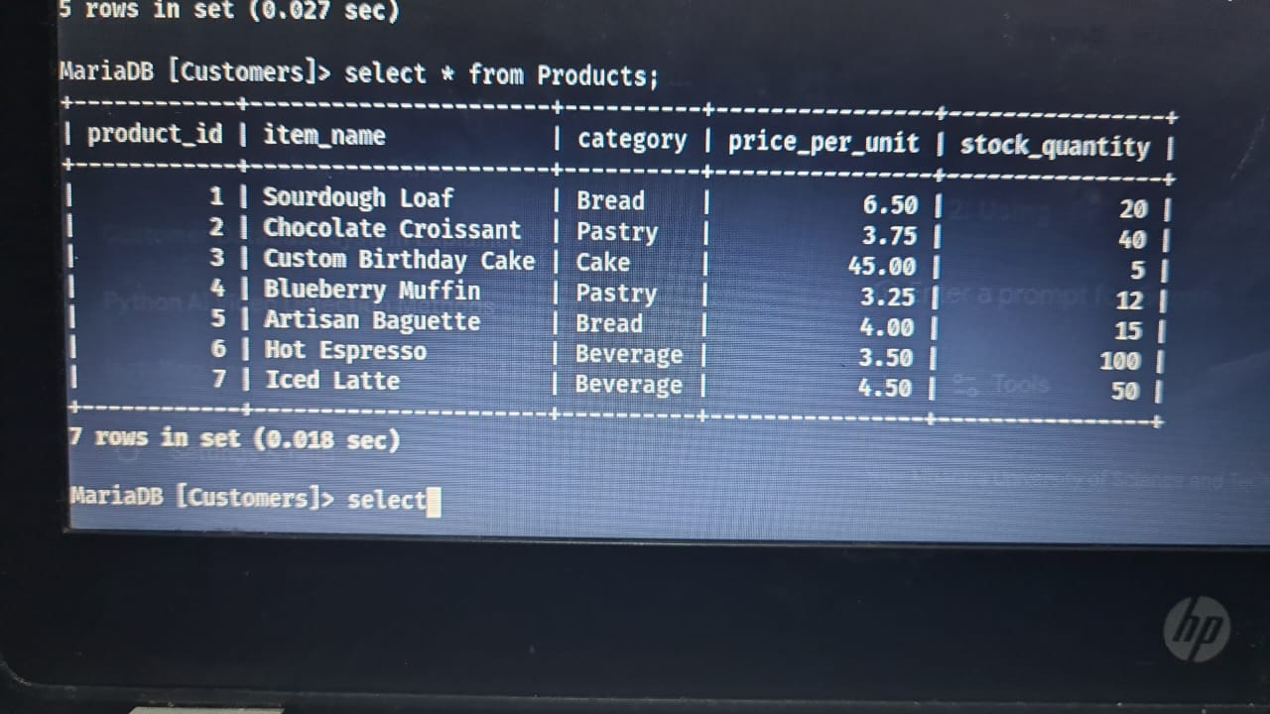

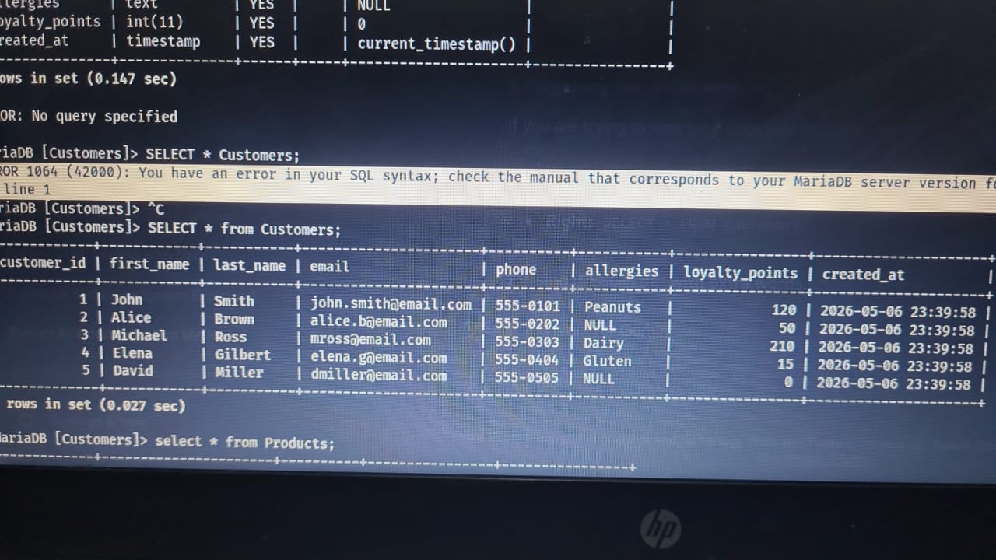

6. Comparison with Real-World Systems
As part of our research, we examined the Square for Retail system used by many local artisanal bakeries. Square utilizes a similar relational structure but incorporates a heavily denormalized 'Transaction' view to speed up reporting. One key takeaway from the Square system was their use of 'Product Variations' (e.g., a loaf of bread being sold 'sliced' or 'whole'). In our next iteration, we plan to implement a many-to-many relationship for product modifiers to better mimic this real-world efficiency.

